Web Team

Candidate Evaluation

The goal of this evaluation is to get an assessment of your knowledge and proficiency in PHP. As with many things in the programming world, many of the questions will have more than one solution. There isn't a time limit on the exam, so take your time and good luck!

Unless otherwise specified, you should assume the following:

* PHP 7.2+
* error_reporting = E_ALL
* Apache >= 2.4
* 64-bit Linux
* MySQL >= 5.7

## PHP

### PHP Section 1: Code Analysis

This section focuses on your ability to analyze, debug, and repair existing php code. The code samples given may emit php error messages, contain logic errors, or fail to run at all.

For each question, please provide as much detail as possible:

1. Identify mistakes, describe what problems they cause, and propose a fix for them.
2. Recommendations for general improvements and an explanation of why the change(s) would improve the code.
3. Predict the output of the corrected code.

#### PHP Question 1.1

Consider that SupportBase is declared elsewhere and successfully loaded by the autoloader.

Given the described class definitions, what is the output of index.php?

Application/Module/Widget.php

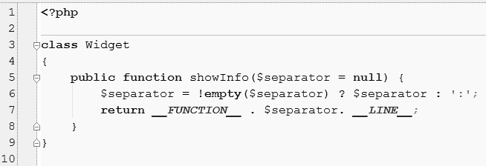

Support/Module/Widget.php

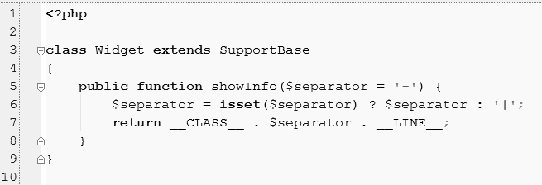

index.php

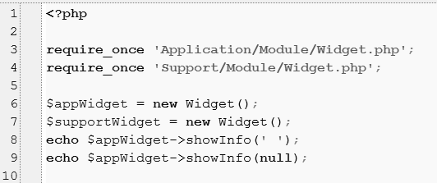

**PHP Answer 1.1**

(Provide your answer below. Use as much space as necessary.)

#### PHP Question 1.2

Consider that the Exam class will be successfully loaded by the autoloader.

Given the described class definition, what is the output of index.php?

Exam.php

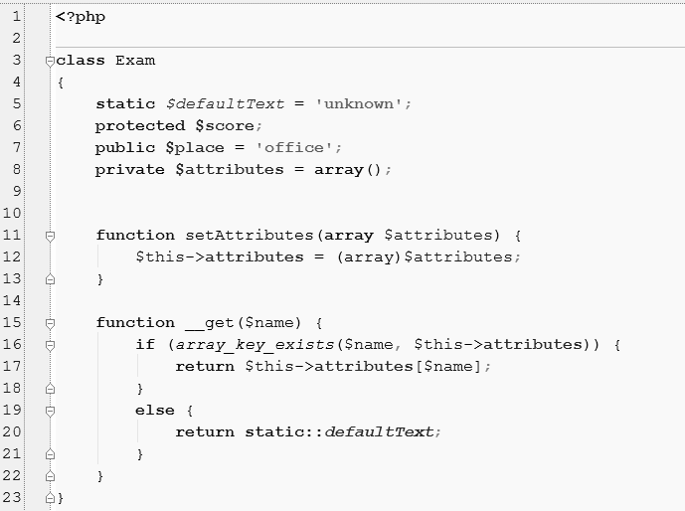

index.php

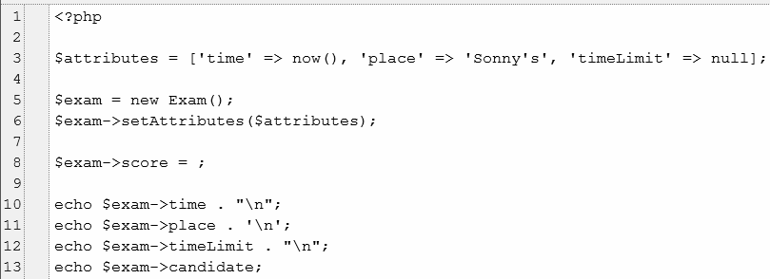

**PHP Answer 1.2**

(Provide your answer below. Use as much space as necessary.)

#### PHP Question 1.3

Assume that the Greeter and InformalGreeter classes will be successfully loaded by the autoloader.

Given the described class definitions, what is the output of index.php?

Greeter.php

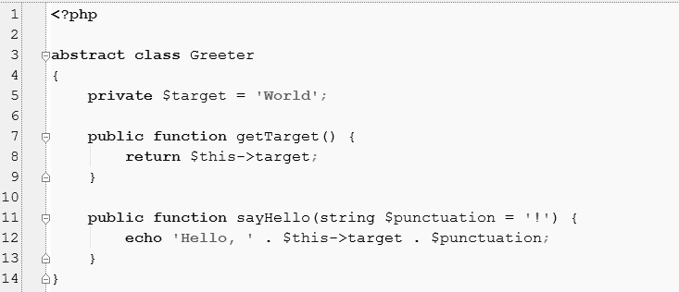

InformalGreeter.php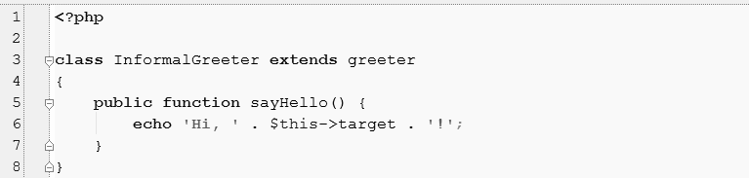

index.php

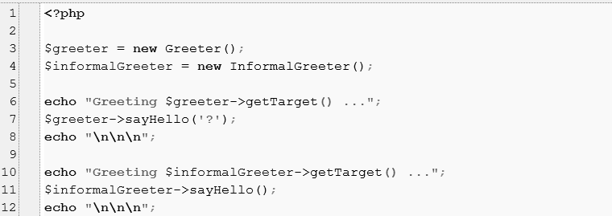  
 **PHP Answer 1.3**  
(Provide your answer below. Use as much space as necessary.)

### PHP Section 2: Code Writing

In this section, you will be required to write actual code according to the instructions given. Your top priority is creating code that meets the functional and technical requirements of each question. However, the code will be evaluated using the following criteria:

1. Accuracy – How well did the code meet the given instructions?
2. Clarity – How easy is it to understand the intent of the code?
3. Syntax – Would the code execute without errors, warnings, and notices?
4. Conciseness – Simple code is good code; is the solution unnecessarily complex?
5. Extensibility – How easily can the code be modified to meet future needs?
6. Best Practices – Does the code follow common coding best practices?

You may use all tools provided to you by the PHP language. You may also add any notes you feel necessary to further explain your coding decisions.

#### PHP Question 2.1

1. Create a class to represent a Person. Each Person must have a first name and a last name. They may also have a middle name.
2. Add a class to represent an Employee. An Employee is a special kind of Person who must have a first name, last name, and employee id. An Employee may also have a middle name.
3. Add a class to represent a Pet. A Pet must have a first name. It may also have a middle name and/or a last name.

**PHP Answer 2.1**(Provide your answer below. Use as much space as necessary.)

#### PHP Question 2.2

Without 3rd party libraries or frameworks, provide a PHP script which:

1. Receives a customer’s last name from a HTTP Get Request
2. Uses the received last name to query a MySQL database for a list of customers with that last name.
3. Uses the result of the query to output a list that displays the full name of every customer with the received last name. The output must also show the user what the original search term was.

**PHP Answer 2.2**

(Provide your answer below. Use as much space as necessary.)

#### PHP Question 2.3

Without altering the given code:

* Represent a universal remote that can turn on a television and a cable box.
* Represent a remote-control user who can push the `power on’ button of a remote control.
* Have a remote-control user push the `power on’ button of a tv remote.
* Have the same remote-control user push the `power on’ button of a universal remote.

|  |
| --- |
| <?php  interface RemoteControl {  public function powerOn();  }  class Television {  public function setPower($state) {  // Truncated Code  }  }  class CableBox {  public function setPower($state) {  // Truncated Code  }  }  class TVRemote implements RemoteControl  {  private $tv;  public function __construct(Television $tv) {  $this->tv = $tv;  }  public function powerOn() {  $this->tv->setPower(true);  }  } |

**PHP Answer 2.3**(Provide your answer below. Use as much space as necessary.)

**PHP Question 2.4**

Provide a Horse, Bird, and Pegasus class given the following rules:

* A Horse gallops.
* A Bird flies.
* A Pegasus flies in *exactly* the same way as a Bird.
* A Pegasus gallops in *exactly* the same way as a Horse.

**Note**: Since galloping and flying are complicated operations, they are assumed to require several lines of non-trivial code. The details of these algorithms are irrelevant to this question. You may represent them in your code using comments. For example:

|  |
| --- |
| function fly() {  // flying code here.  } |

**PHP Answer 2.4**

(Provide your answer below. Use as much space as necessary.)

## MySQL

### MySQL Question 1

Considering the query below, if you needed to add the **tbl3** slug field into the result set how would you do it?

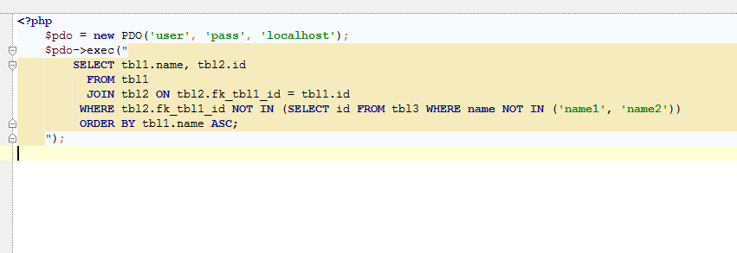

**MySQL Answer 1**(Provide your answer below. Use as much space as necessary.)

### MySQL Question 2

The following query throws a duplicate primary key error and blocks a cron job to move forward. How can this query be changed so the error is not thrown, and the record is updated?

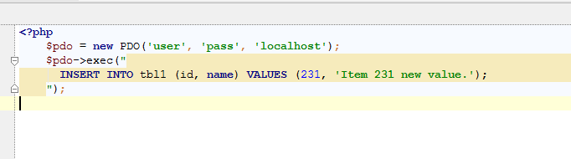

**MySQL Answer 2**   
(Provide your answer below. Use as much space as necessary.)

## Linux

### Linux Question 1

The PHP application running is throwing a massive number of errors, warnings, notices on the logs and you need to try to look for a specific error on the error logs. On the command line how can you achieve this?

**Linux Answer 1**   
(Provide your answer below. Use as much space as necessary.)

### Linux Question 2

Support calls and informs that the PHP application site is running very slow and hanging. The users can’t login or even logout. A page request takes so long that Apache throws a timeout error. Considering that you have a standard PHP application and that it connects to a MySQL database that lives in another server and all your apache, MySQL and PHP configurations are correct, what steps would you take to troubleshoot the issue?

**Linux Answer 2**  
(Provide your answer below. Use as much space as necessary.)